Assignment : 18.3
API Integration: Connecting to External Services
with Error Handling
Lab Objectives:
• Learn how to integrate Python programs with external REST
APIs.
• Understand API request/response handling using requests or
similar libraries.
• Implement proper error handling for failed API calls
(timeouts, invalid responses, rate limits).
• Practice extracting and displaying meaningful information
from API responses.
Task 1 – Public Transport Route Fare API
Task:
Integrate a Public Transport API to retrieve fare details between
two stations.
Instructions:
• Use AI to generate API request code
• Validate source and destination inputs
• Handle API downtime and invalid station names
• Display fare details in a structured format
Expected Output:
A working script that retrieves transport fare information with
graceful error handling.
🔹 Prompt
Generate Python code using requests to fetch fare between two stations via a public transport API with input validation and error handling (invalid stations, timeout, API failure).
Display fare details (source, destination, fare) in a structured format.
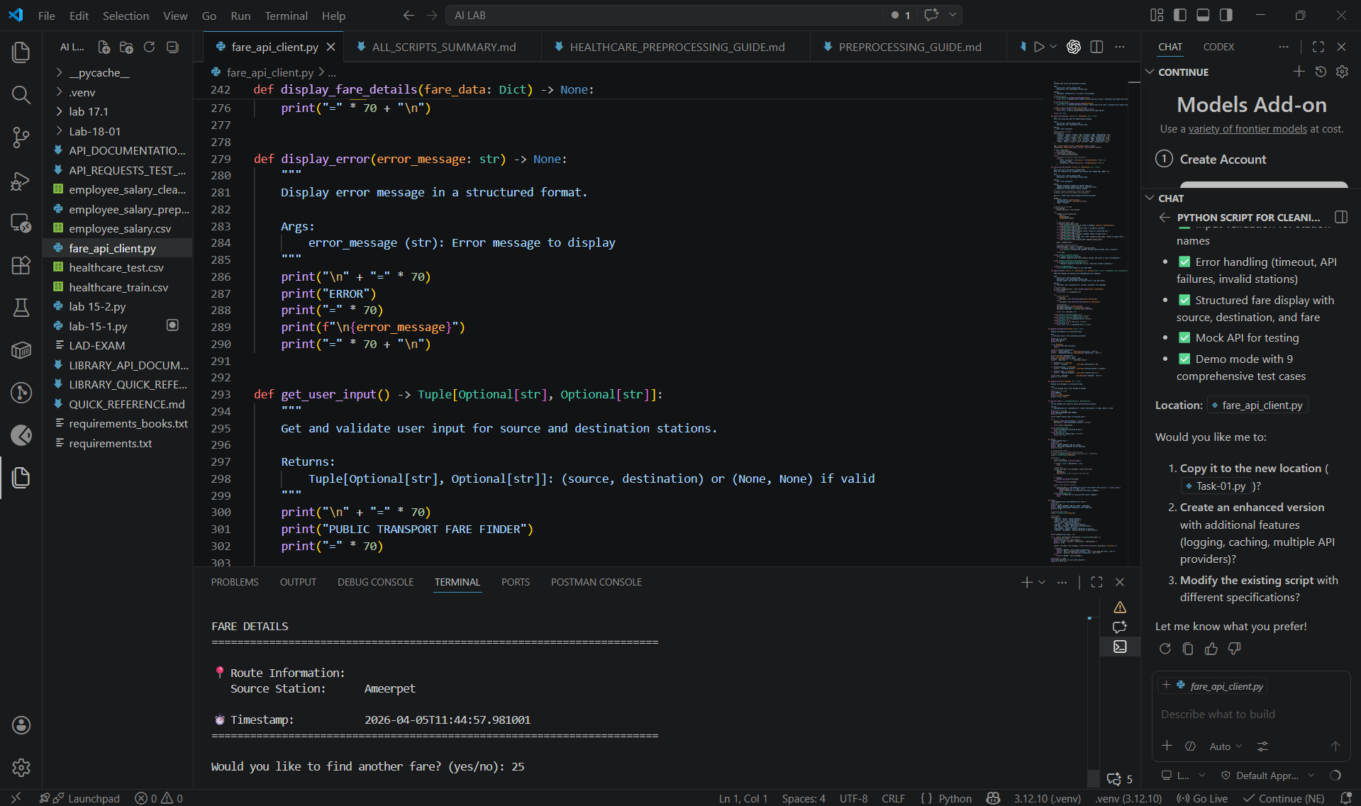
Task 2 – Currency Exchange Rates
Task:
Integrate a Currency Exchange API to convert INR to USD,
EUR, and GBP.
Instructions:
• Use AI to generate API request code.
• Validate user input for amount and currency codes.
• Implement error handling for invalid responses and API
downtime.
• Show conversion results clearly in tabular format.
Expected Output:
• A script that converts INR to multiple currencies with
graceful error handling.
🔹 Prompt
Generate Python code using requests to convert INR to USD, EUR, GBP with user input validation and API error handling.
Display results in a clear tabular format.
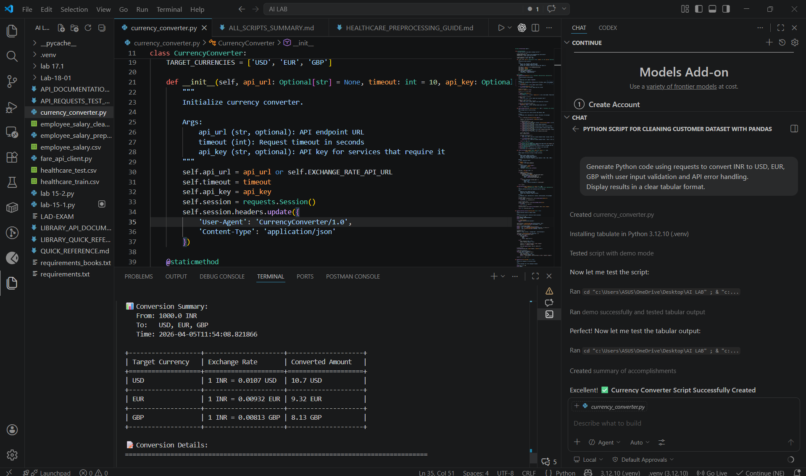
Task 3 – GitHub Repository Info Fetcher
Task:
Connect to the GitHub API to fetch details of a repository (e.g.,
stars, forks, issues).
Instructions:
• Prompt AI to write a Python function to send GET requests
to GitHub API.
• Handle rate limit errors, 404 (repo not found), and invalid
input.
• Display repository name, description, stars, forks, and open
issues.
Expected Output:
• A Python program that retrieves and displays GitHub
repository information with robust error handling.
🔹 Prompt
Generate Python code using requests to fetch GitHub repo details (stars, forks, issues) with error handling for 404, rate limits, invalid repo.
Display repo name, description, stars, forks, open issues.
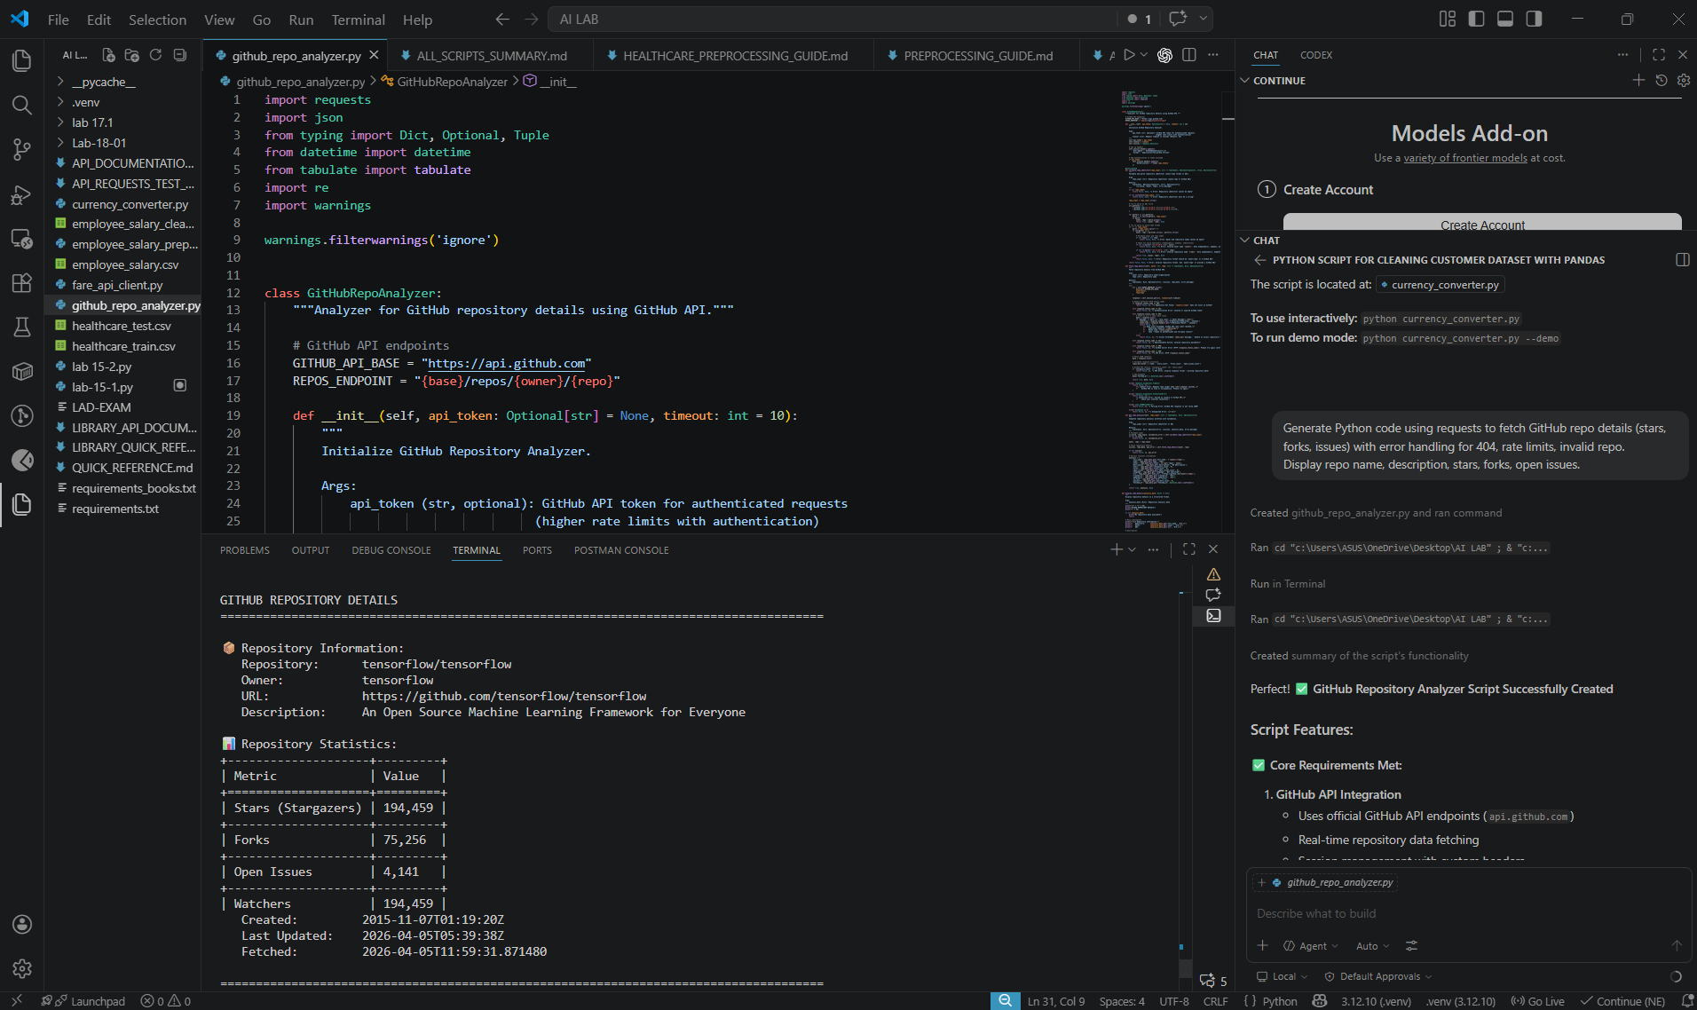
Task 4 – Real-Time Application: News Headlines Aggregator
Scenario:
Build a News Aggregator using a free News API.
Requirements:
• Fetch top 5 headlines for a given category (sports,
technology, health).
• Handle errors like invalid category, missing API key, and
request failures.
• Display headlines in a user-friendly numbered list format.
• Include a retry mechanism if the first request fails.
Expected Output:
• A working Python script that retrieves and displays news
headlines with proper error handling
🔹 Prompt:
Generate Python code using requests to fetch top 5 news headlines by category with retry logic and error handling (invalid category, API failure, missing key).
Display headlines in numbered list format.
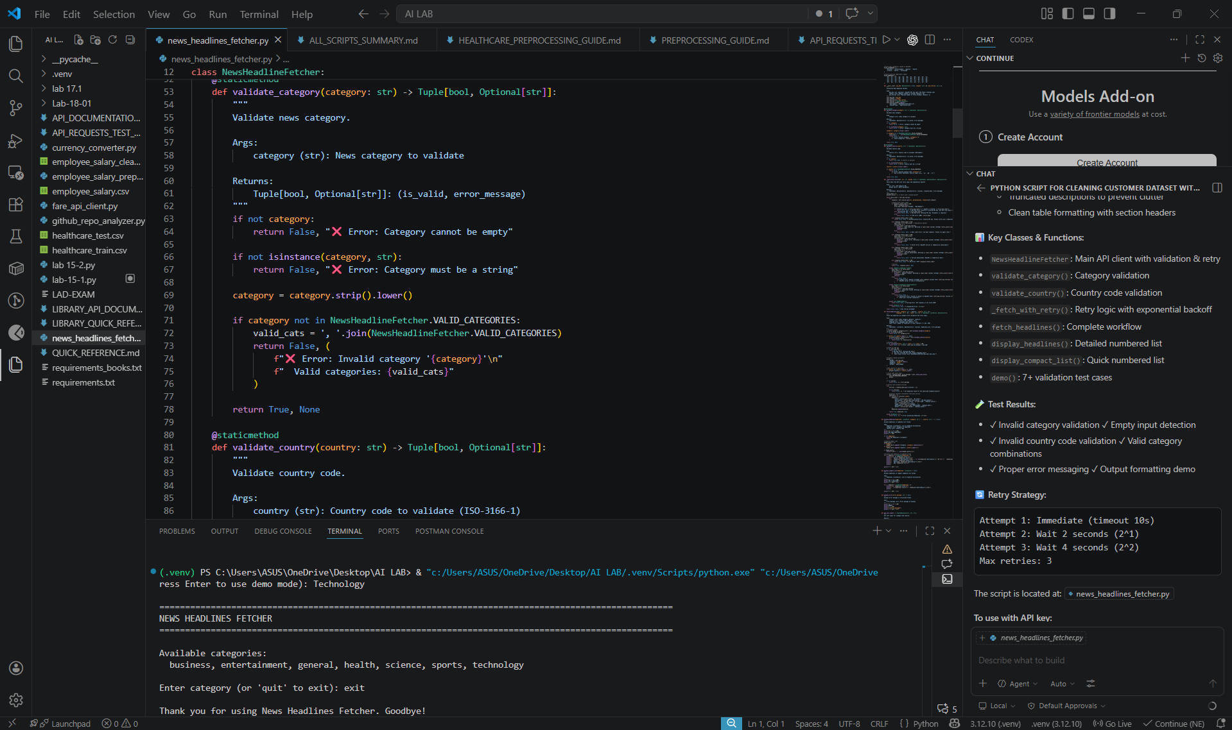
Task 5 -COVID-19 Statistics API Integration
Task:
Connect to a COVID-19 Statistics API to fetch country-wise
COVID data.
Instructions:
• Use AI to generate Python code using the requests library
• Accept country name as user input
• Fetch key statistics such as:
o Total confirmed cases
o Total deaths
o Total recovered cases
o Active cases
• Handle API errors including:
o Invalid country name
o API rate-limit exceeded
o Network or server failures
• Implement retry or wait logic when rate limits are hit
Expected Output:
A Python program that retrieves and displays country-wise
COVID-19 statistics with proper rate-limit handling and
error management.
Note: Report should be submitted as a word document for all tasks in a
single document with prompts, comments & code explanation, and output
and if required, screenshots.
🔹 Prompt:
Generate Python code using requests to fetch COVID-19 stats by country with input validation, rate-limit handling, and retry logic.
Display confirmed, deaths, recovered, active cases.
